The Tiling Game - Sensorial

This work consists of three stages:

- Sensorial exploration (can be shown to 6-yr. olds so they familiarize themselves with the shapes of the Geometry Cabinet)

- Analytical exploration
- (pre-requisite: angles)

- Calculation of area
- (pre-requisite: area of triangles, quadrilaterals, circle)

MATERIAL:
- a ‘floor’, which is a board of at least 60 x 40cm
- ‘tiles’: at least 6 copies of each of the following shapes (all the shapes have the same dimensions as those found in the Geometry Cabinet)
  - equilateral triangle (red)
  - square (yellow)
  - circle (blue)
  - hexagon (gold)
  - rectangle (5 x 10cm) (brown)
  - rhombus (made out of two equilateral triangles) (light green)
  - pentagon (dark green)
  - heptagon (pink)
  - octagon (army green)
  - nonagon (orange)
  - decagon (light brown)
  - 1st flower (square + four half-circles) (light blue)
  - quatrefoil (square + four ¾ circles) (orange)
  - one interstice for each shape that requires it
    - Note: Interstices are the spaces between shapes that appear when (usually) four shapes are brought together. You can either print the black-line interstices on pages 11, 14, 15 or the grey ones that appear between the colored shapes starting on page 29 of the printable.

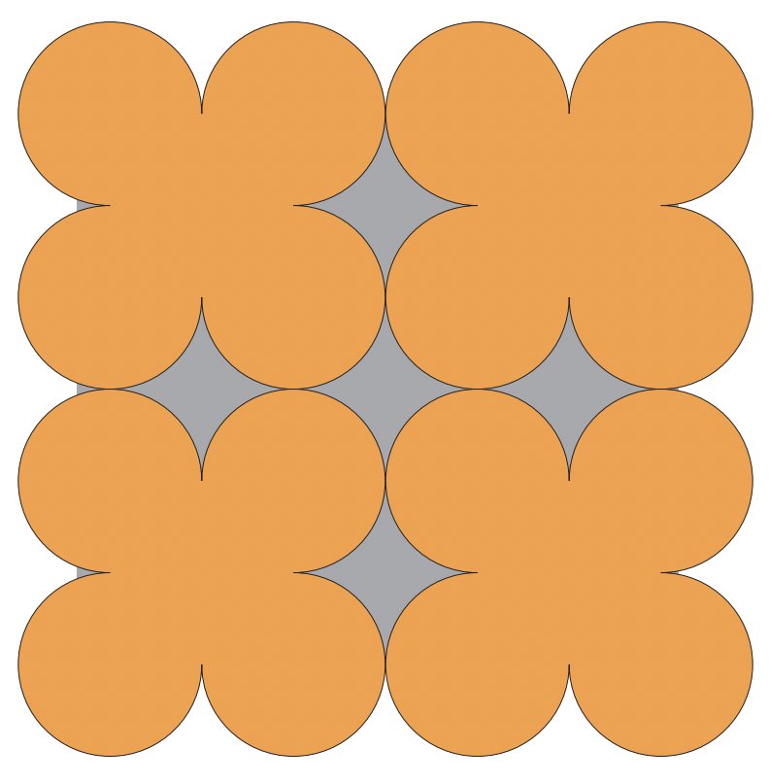

Note: Your colors don’t have to match the ones on this list, but the shapes do need to be of different colors.

→ IMPORTANT PRINTING NOTE: When you print the shapes, either print the full color shapes on white cardstock OR the black/white outline shapes on colored cardstock (a different color for each shape). You will have to select the pages to print based on whether you have white or colored cardstock. Remember that you need at least 6 of each shape, but if you have more that makes it more fun! Your paper colors don’t have to match the colors on the list above.

DIY printable material here.

Stage I: Sensorial Exploration

Exploration #1: Yes or No
- Do a quick orientation of basic shape recognition.
- Explain to the children: We want to use these shapes, one shape at a time, to create a pattern with which we can cover the floor without gaps.
- Bring out two labels: yes and no
- Invite the child to choose one shape and try to tile the floor with it. If he chooses a shape like the circle, it will not be possible to tile the floor without gaps.
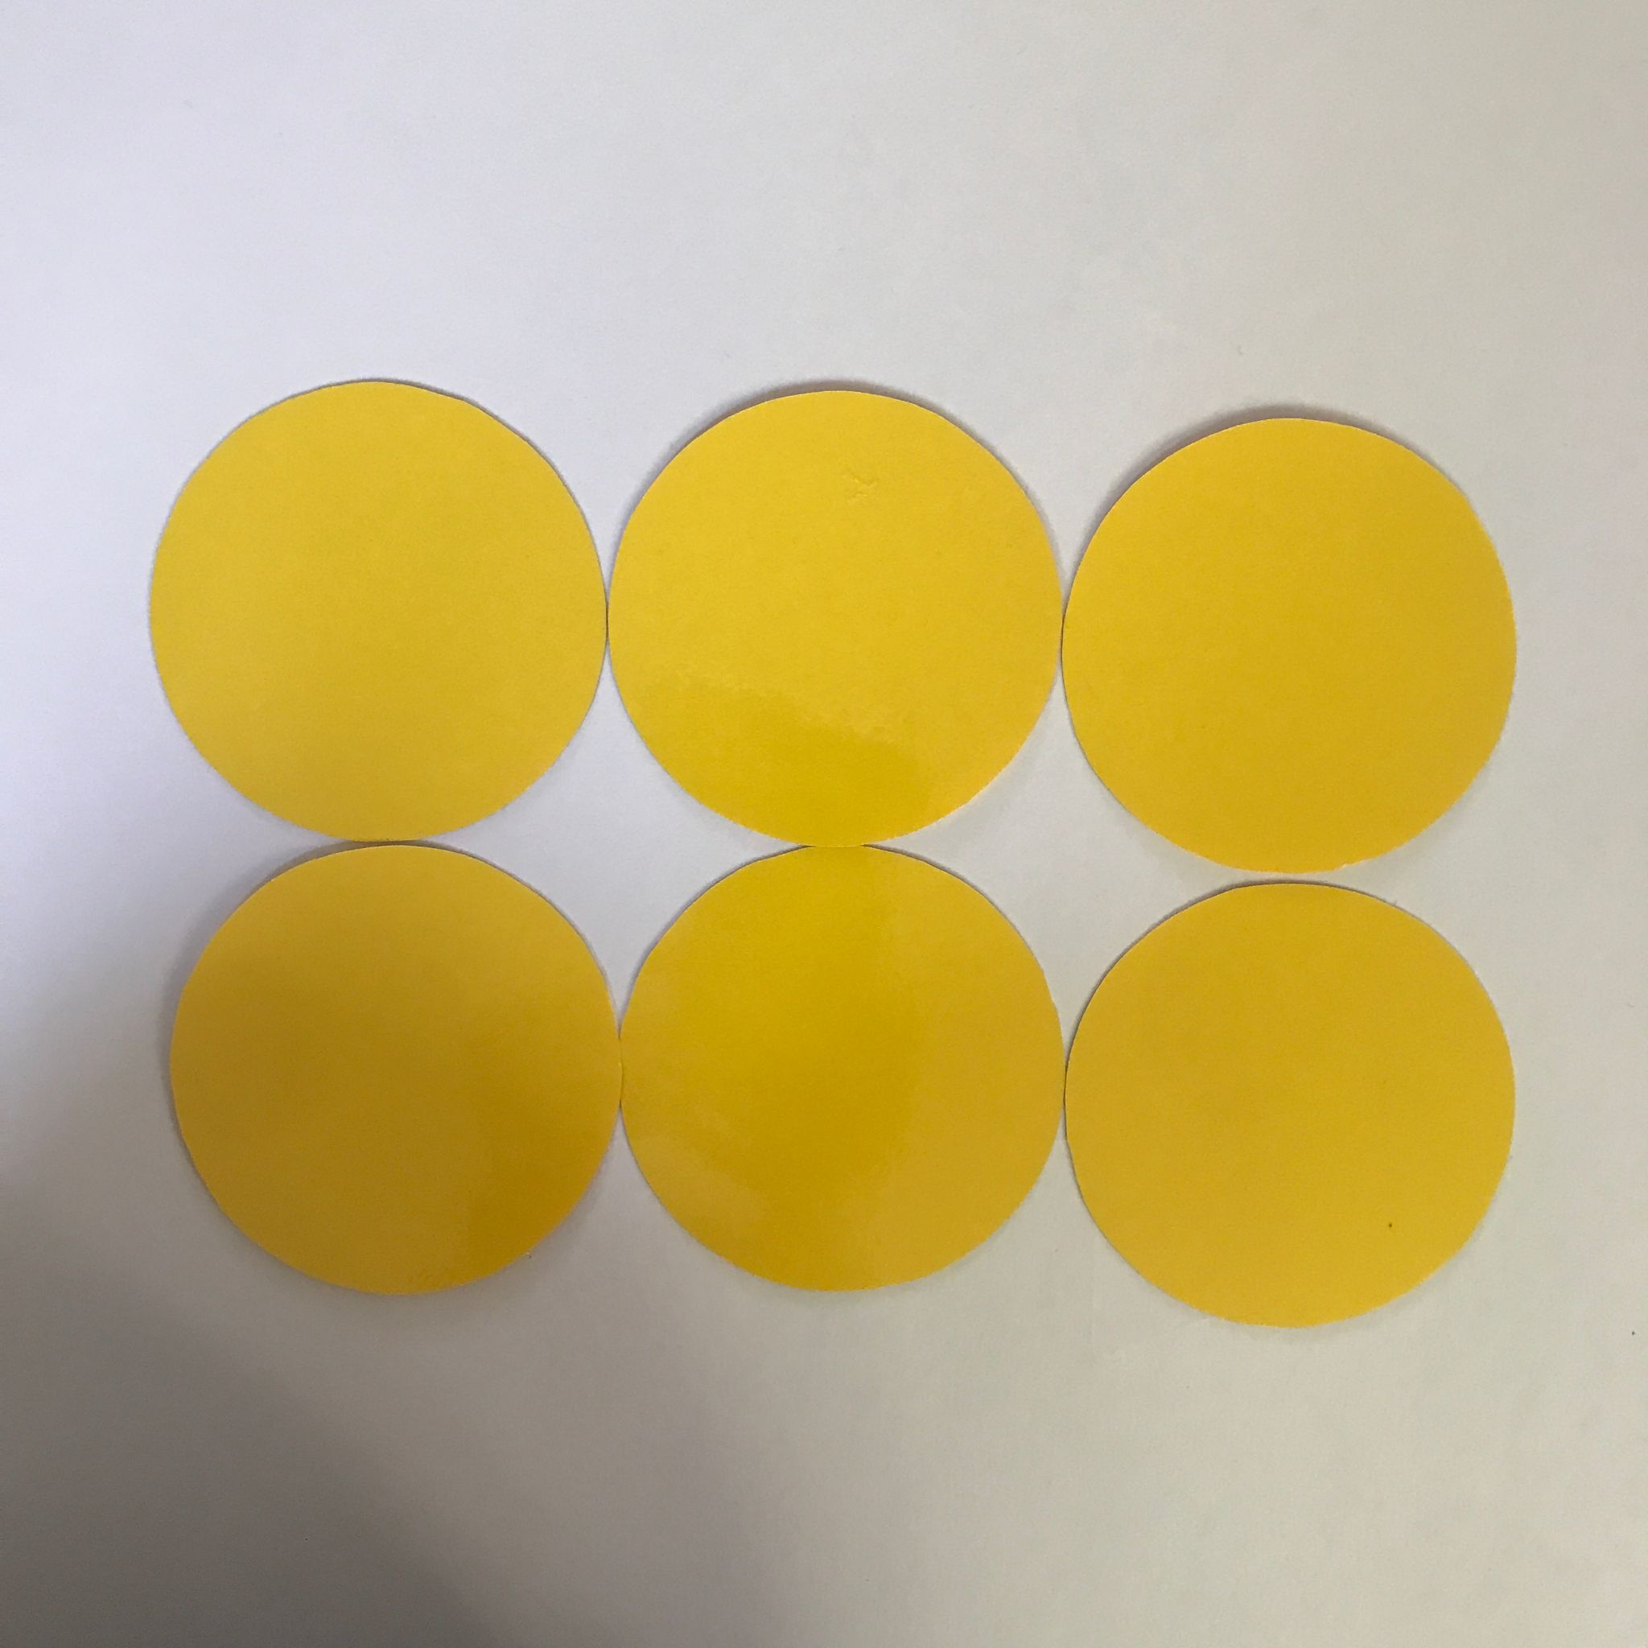
- He can put the circle under the label “no”.
- If he tries a shape with straight sides, these have to match perfectly while trying to get the shapes as close as possible one to the other. (Note: not all shapes with straight sides will tile perfectly.)
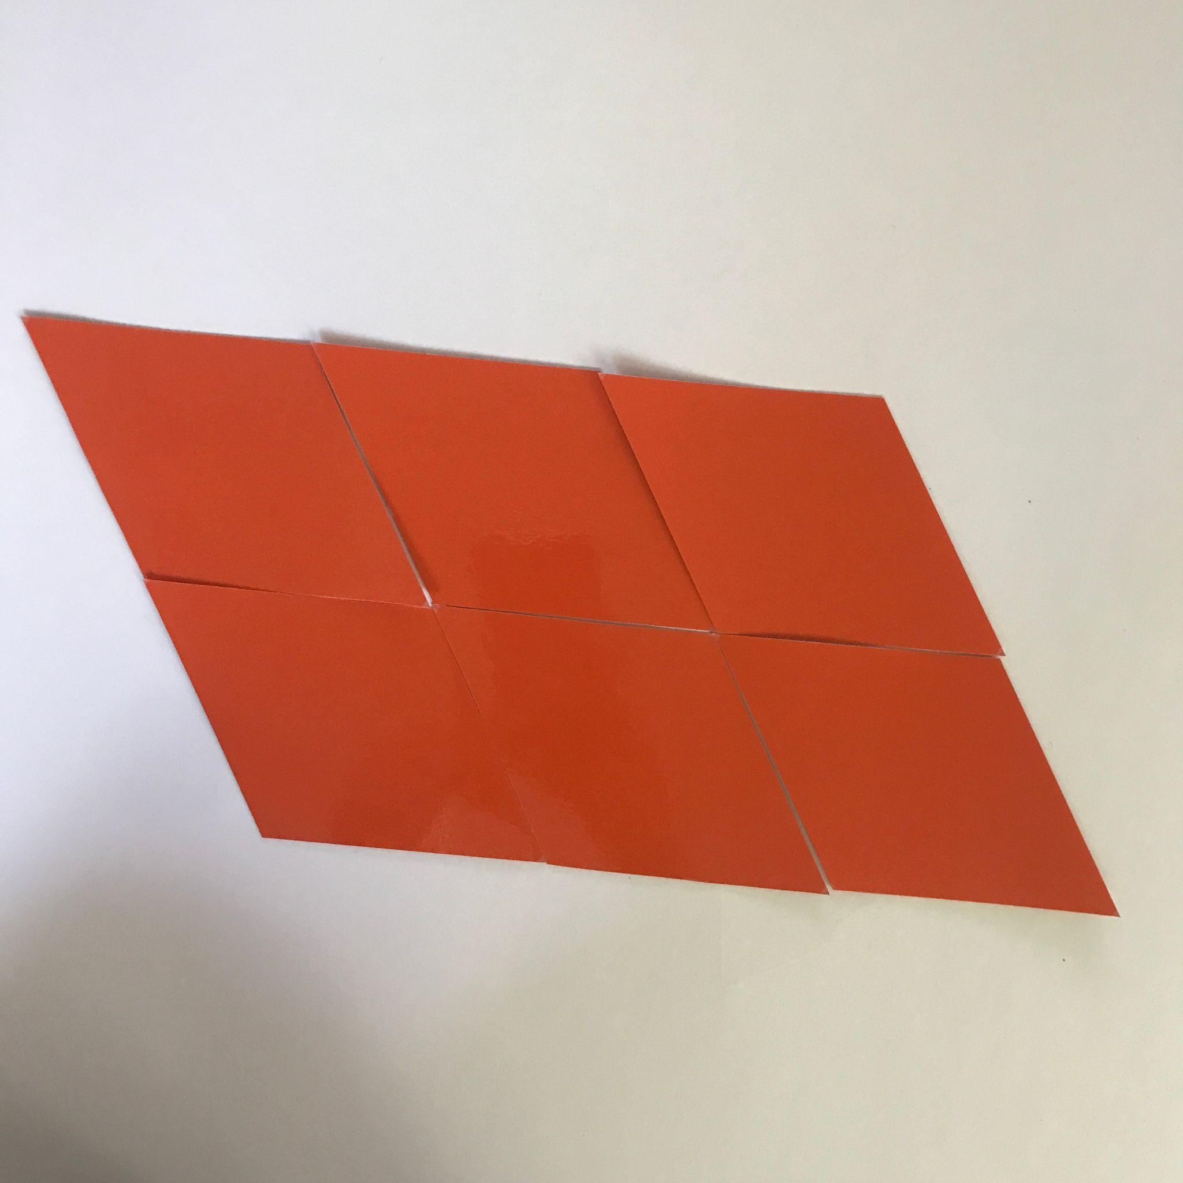
- The child will discover that the “yes” figures are: hexagon, rhombus, rectangle, triangle, and square. The rest of the shapes are “no” shapes, meaning they cannot be used on their own to tile the floor without gaps.
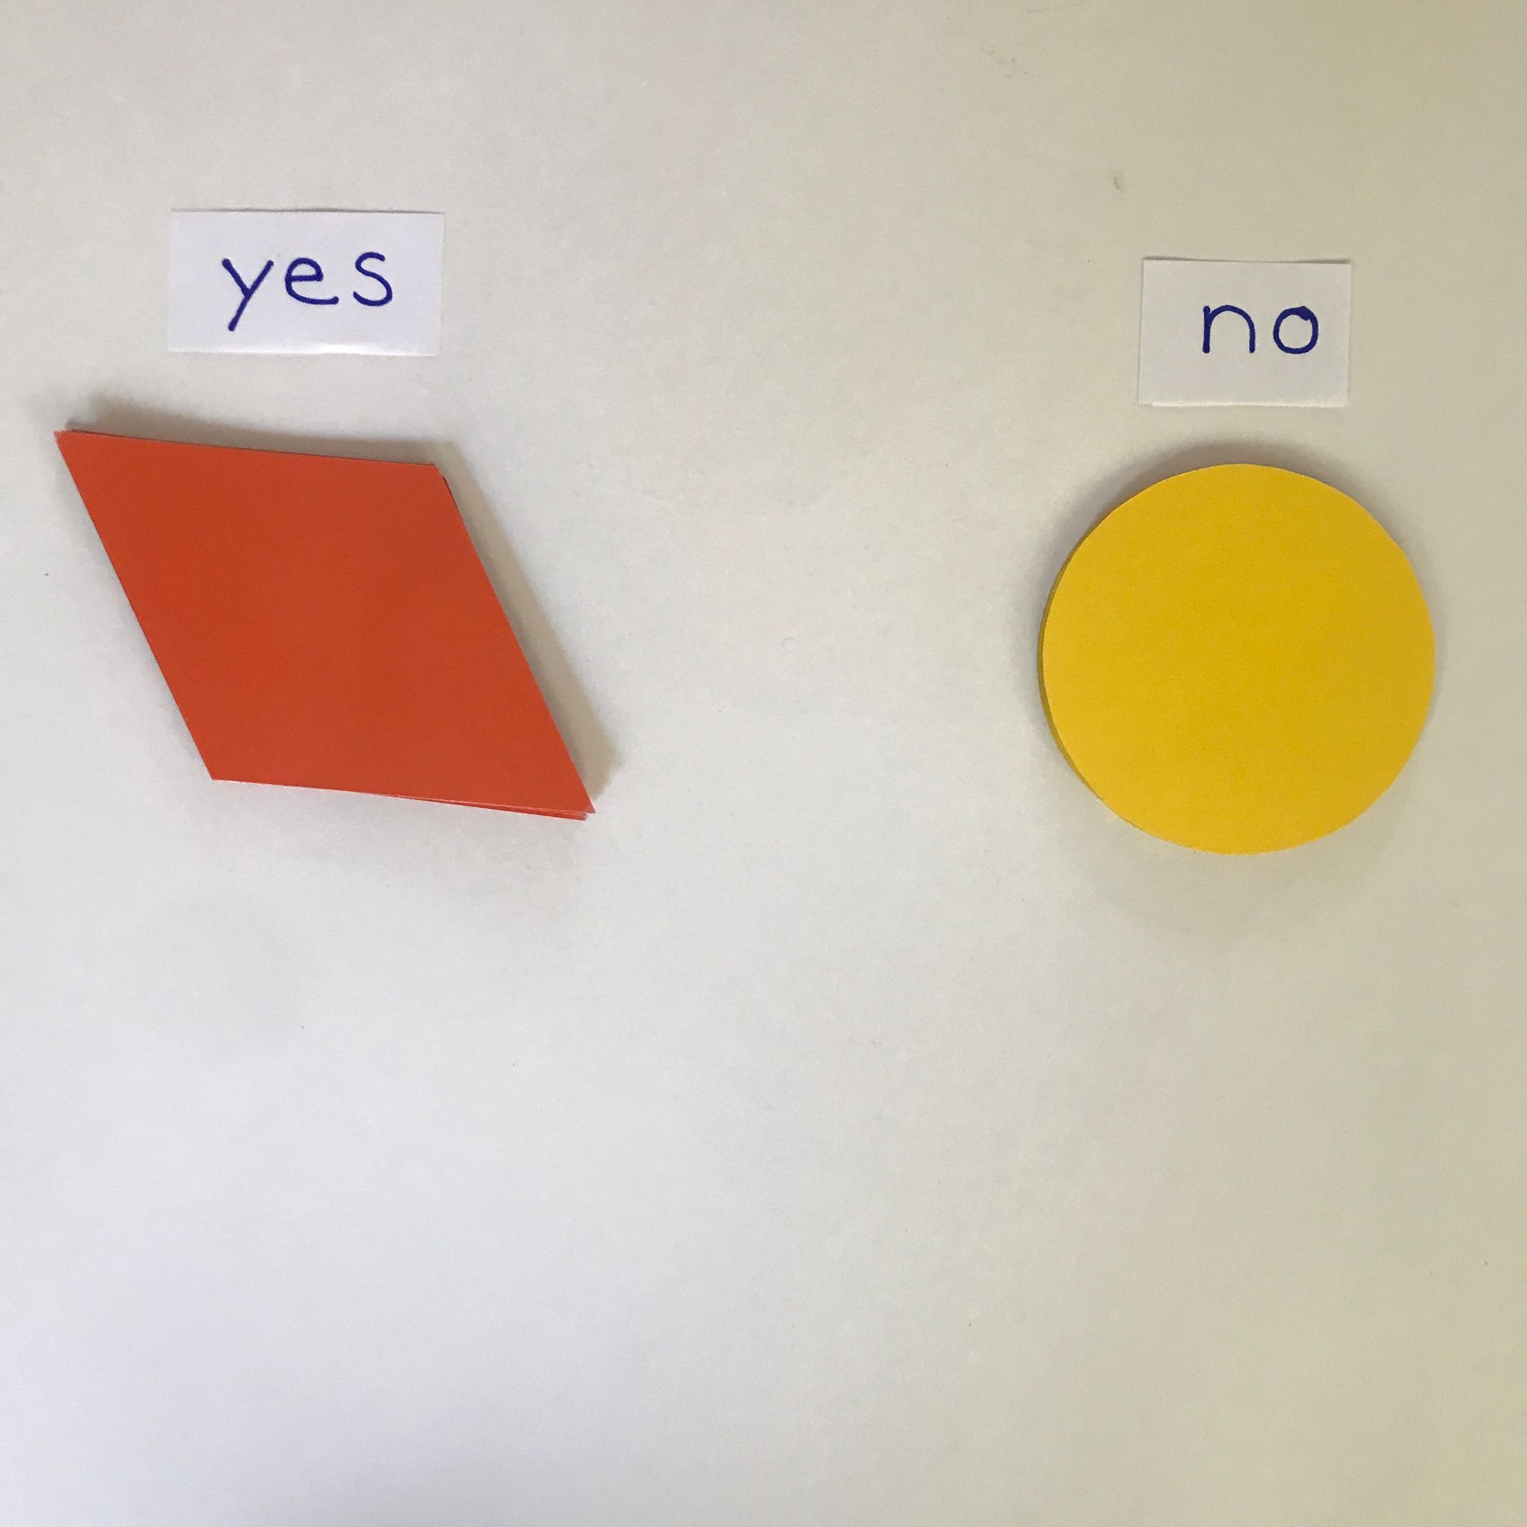

Exploration #2: How many ways?
- Focus on the “yes” figures.
- Invite the children to see how many ways they can lay out one type of tiles. There are two ways of laying out the squares, two ways of laying out the triangles, many ways of laying out the rectangles, etc.
- The children can draw the shapes on paper to reproduce the pattern and see if it repeats.
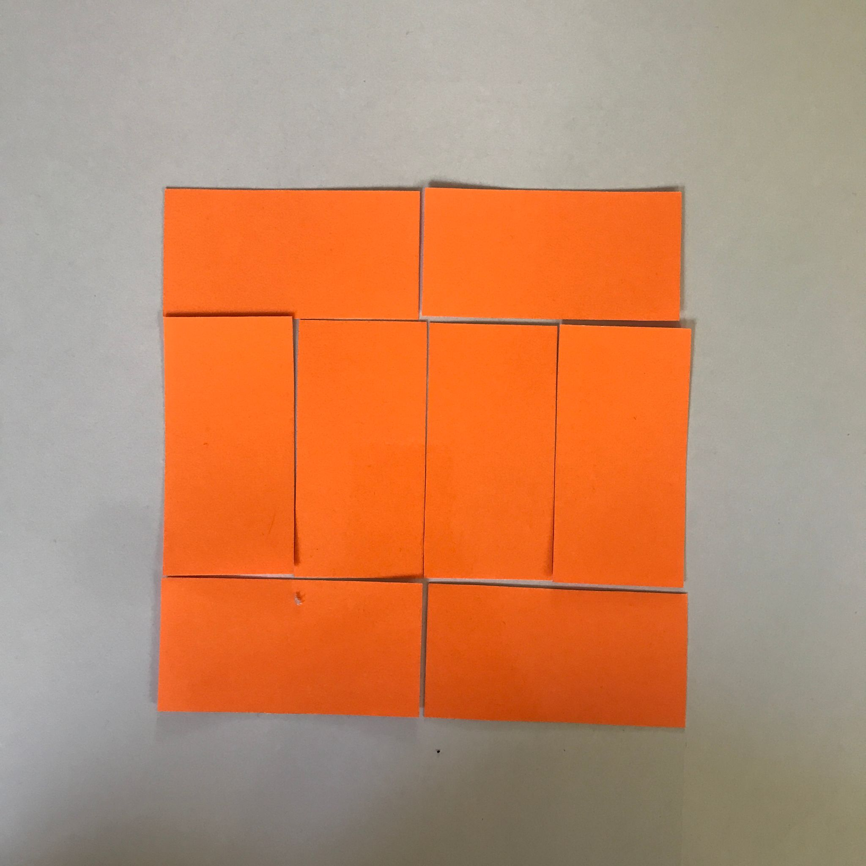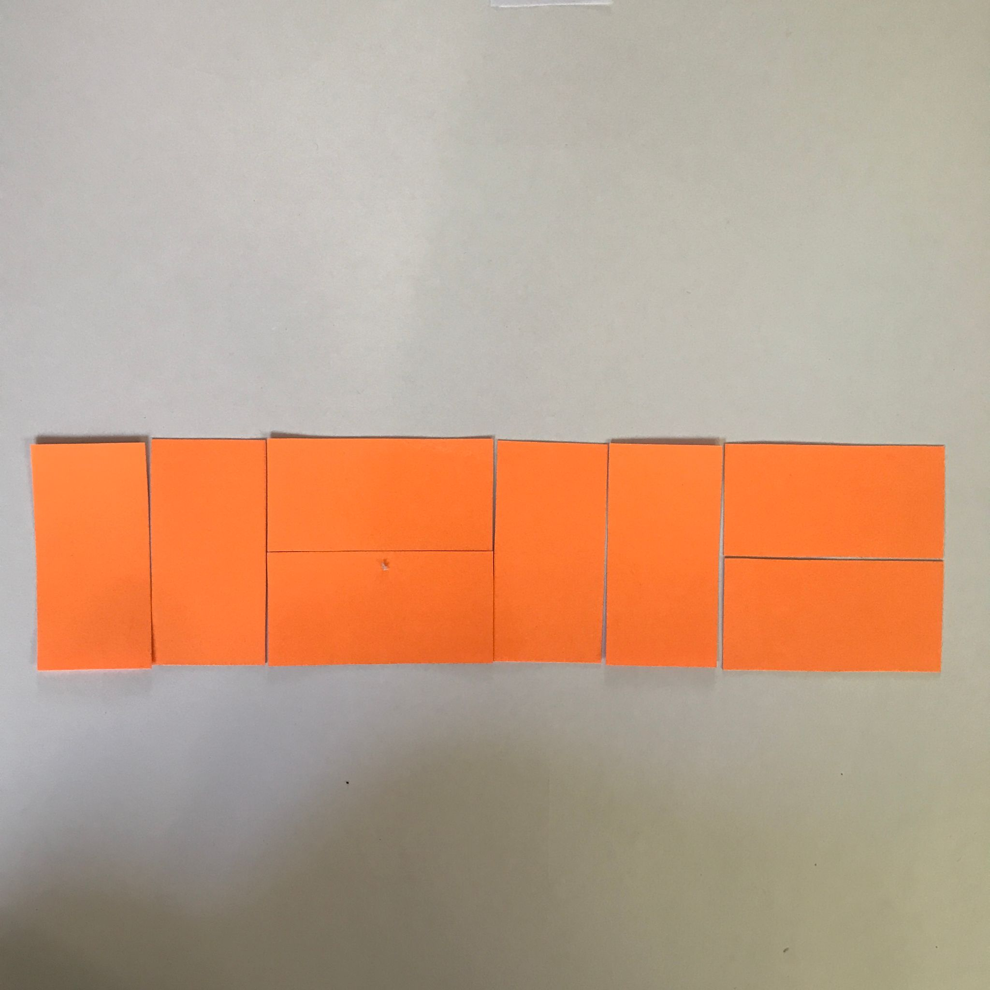

Exploration #3: Repeating patterns
- Invite the children to combine “yes” figures to see if they can form a pattern that repeats. They can use two or more figures at the same time.
- They can work on a mat or large flat surface if they need more space. They can also reproduce the shapes on heavy colored paper to confirm pattern repetition.
